|  |
| --- |
|  |

|  |
| --- |
| **Swiss Chard, 4** |

|  |
| --- |
|  |

|  |
| --- |
|  |

|  |
| --- |
|  |

|  |
| --- |
|  |

|  |
| --- |
|  |

|  |
| --- |
|  |

|  |
| --- |
|  |

|  |
| --- |
|  |

|  |
| --- |
|  |

|  |
| --- |
|  |

|  |
| --- |
|  |

|  |
| --- |
|  |

|  |
| --- |
|  |

|  |
| --- |
|  |

|  |
| --- |
|  |

|  |
| --- |
|  |

|  |
| --- |
|  |

|  |
| --- |
|  |

|  |
| --- |
|  |

|  |
| --- |
|  |

|  |
| --- |
|  |

|  |
| --- |
|  |

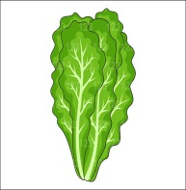

**Lettuce, 4**



**Lettuce, 4**



**Lettuce, 4**



**Lettuce, 4**

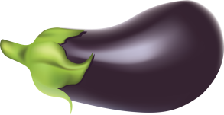

**Eggplant, 1**



**Eggplant, 1**



**Eggplant, 1**



**Eggplant, 1**

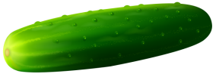

**Cucumber, 2**



**Cucumber, 2**



**Cucumber, 2**



**Cucumber, 2**

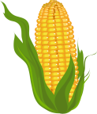

**Corn, 4**



**Corn, 4**



**Corn, 4**



**Corn, 4**

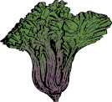

**Swiss Chard, 4**



**Swiss Chard, 4**



**Swiss Chard, 4**

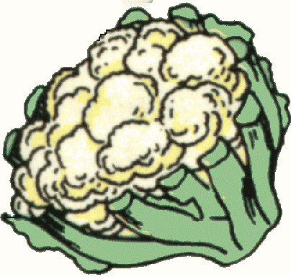

**Cauliflower, 1**



**Cauliflower, 1**



**Cauliflower, 1**



**Cauliflower, 1**